Networking Fundamentals for Defenders
  - TechBiz Academy | SOC Analyst Internship | Week 1 – Task 2

1. Introduction
Networking is one of the fundamental areas of knowledge required by a Security Operations Center (SOC) analyst. Understanding how devices communicate, which protocols they use, and how data travels across a network helps analysts identify suspicious activities and investigate potential security incidents.
A SOC analyst must be able to distinguish legitimate network communication from unusual behavior. For example, an employee accessing a shared folder during working hours may be normal, whereas the same workstation attempting to access numerous internal systems late at night could require investigation.
This report documents my understanding of networking fundamentals, common protocols, DNS resolution, and how these concepts can be applied to network traffic analysis from a defensive security perspective.

2. Objectives of the Task
The objectives of this task were to:
- Understand the seven layers of the OSI model and how network communication occurs.
- Learn about encapsulation and decapsulation.
- Identify commonly used network ports and their associated protocols.
- Understand the differences between TCP and UDP.
- Explain the DNS resolution process.
- Recognize normal and potentially suspicious network traffic.
- Complete the assigned TryHackMe networking rooms.
- Apply networking knowledge to practical SOC investigation scenarios.

3. OSI Model
The Open Systems Interconnection (OSI) model is a conceptual framework that describes network communication through seven layers. Each layer has a specific responsibility and helps explain how data is transmitted between devices.
Layer | Name | Function
7 | Application | Provides network services to applications; HTTP, DNS, SMB
6 | Presentation | Data representation, encoding, compression and encryption
5 | Session | Establishes and manages communication sessions
4 | Transport | End-to-end transport using TCP or UDP
3 | Network | Logical addressing and routing using IPv4 or IPv6
2 | Data Link | Local network delivery using Ethernet frames and MAC addresses
1 | Physical | Transmits bits as electrical, optical or radio signals

4. Common Network Ports and Protocols
Network ports help identify services running on devices and allow multiple applications to communicate over a network. Knowing common ports is important because security alerts frequently contain source and destination IP addresses, port numbers and protocol information.
Port | Protocol | Purpose
20/21 | FTP | File transfer, including FTP control and traditional data connections
22 | SSH | Secure remote administration
25 | SMTP | Email transfer
53 | DNS | Domain name resolution
80 | HTTP | Unencrypted web communication
110 | POP3 | Email retrieval
143 | IMAP | Email retrieval and mailbox access
443 | HTTPS | Encrypted web communication
445 | SMB | Windows file and printer sharing
3389 | RDP | Remote desktop access

5. DNS Resolution Process
The Domain Name System (DNS) translates domain names into information such as IP addresses, allowing users and applications to locate network services without remembering numerical addresses.
When a user enters a domain name into a browser, the system attempts to resolve that name into an address that can be used to establish network communication.
Step-by-Step DNS Resolution
A simplified DNS resolution process is:
- The device checks applicable local name-resolution sources, such as the hosts file and local DNS cache.
- If the answer is unavailable locally, the device sends a DNS query to its configured resolver.
- If the resolver does not already have the answer, it may perform recursive resolution or forward the request to another resolver.
- During recursive resolution, a root DNS server can direct the resolver toward the relevant top-level domain (TLD) servers.
- The TLD server can identify the authoritative name servers responsible for the requested domain.
- The authoritative server provides the appropriate DNS response, such as an A or AAAA record.
- The resolver returns the response to the client, and the answer may be cached according to applicable caching rules.

6. Practical Learning — TryHackMe
As part of this task, I completed three assigned TryHackMe rooms covering networking fundamentals.
What is Networking?
This room helped reinforce foundational networking concepts and how devices communicate over networks.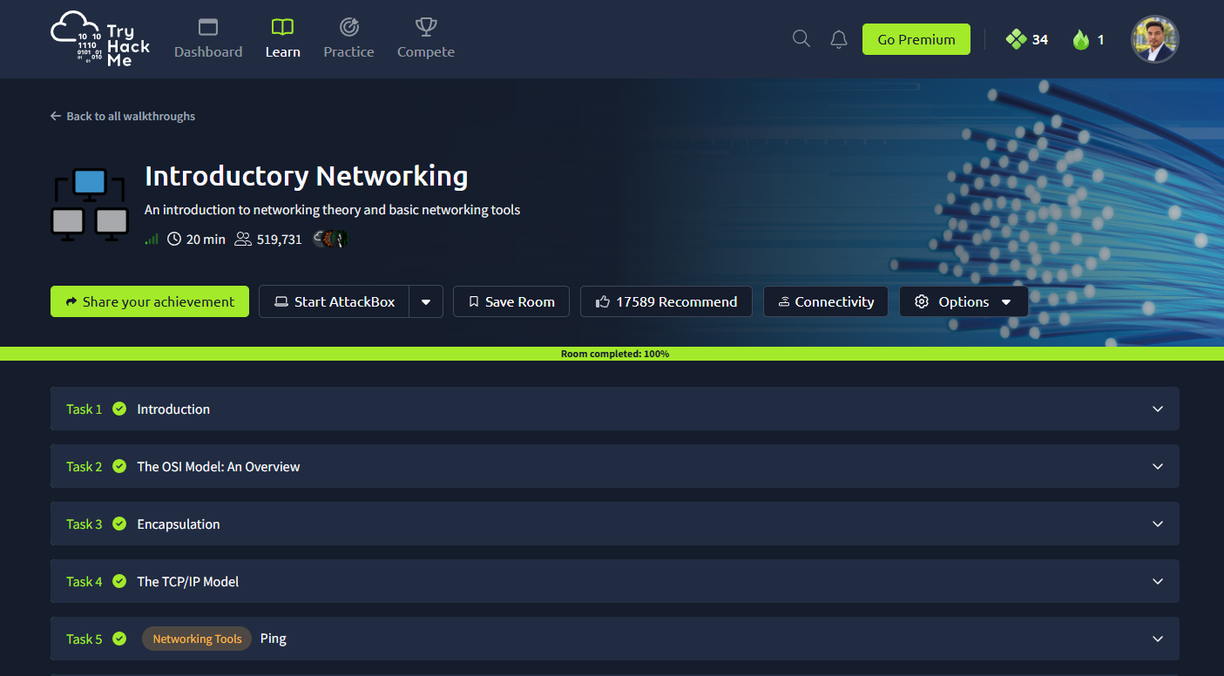

Introductory Networking
This room covered concepts including the OSI model, encapsulation, TCP/IP and network troubleshooting tools such as ping.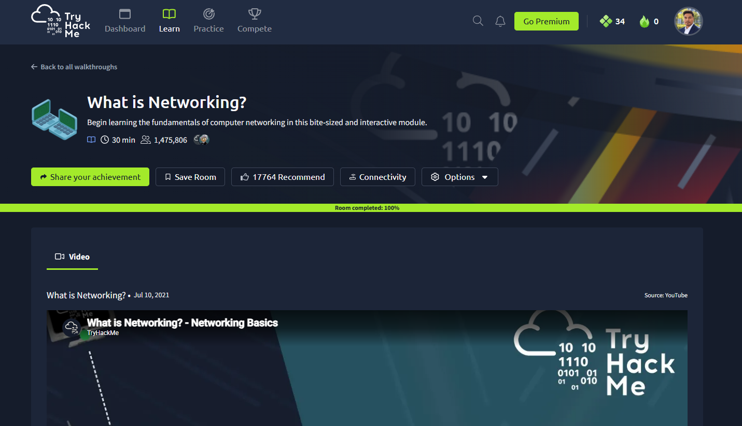
DNS in Detail
This room helped reinforce the DNS resolution process and the role of DNS infrastructure in translating domain names into network addresses.
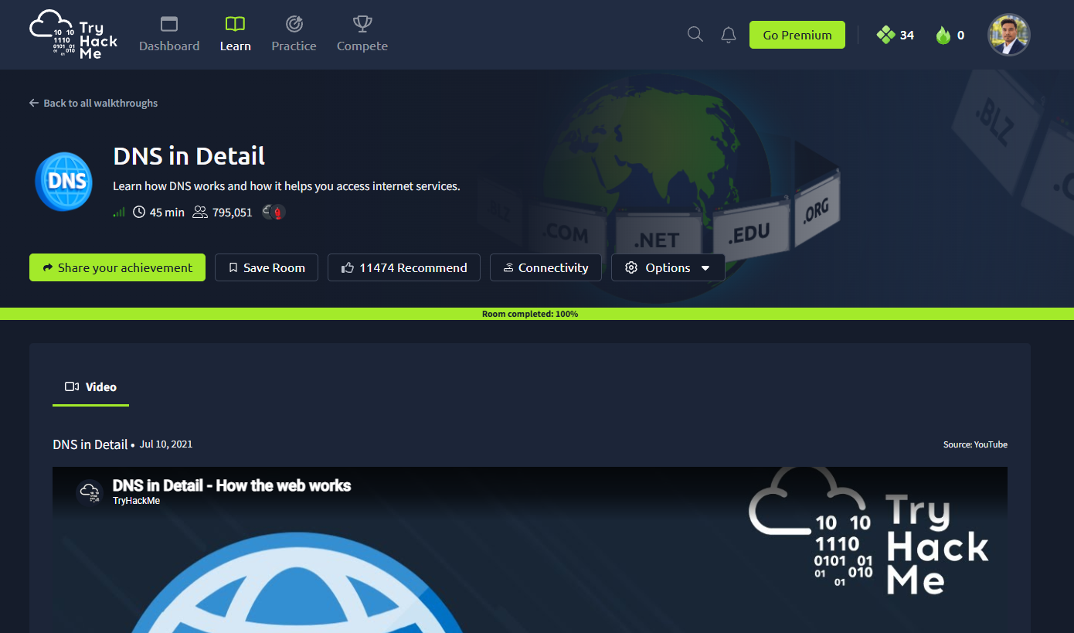

7. Key Learning Outcomes
Through this task, I developed a stronger understanding of networking from a defensive security perspective.
My key learning outcomes include:
- Understanding how the OSI model helps organize and interpret network communication.
- Explaining encapsulation and the role of protocol headers in transmitting data.
- Recognizing common network ports and their security relevance.
- Differentiating between TCP and UDP communication.
- Explaining the DNS resolution process.
- Identifying patterns that may indicate SSH scanning, SMB lateral movement or DNS tunneling.
- Understanding why suspicious traffic requires contextual investigation before reaching a conclusion.
- Recognizing when correlated high-risk indicators justify prompt escalation.

8. Conclusion
Networking fundamentals are essential for understanding how security incidents can be identified through network activity.
This task helped me connect theoretical networking concepts with practical SOC investigation scenarios. I learned that identifying a protocol or port is only the beginning of an investigation. A SOC analyst must also consider communication patterns, user behavior, timing, authorization and supporting evidence.
The TryHackMe exercises and scenario-based investigations strengthened my understanding of how networking knowledge supports security monitoring, incident triage and escalation.

9. References and Supporting Evidence
TryHackMe learning resources
- What is Networking? — https://tryhackme.com/room/whatisnetworking
- Introductory Networking — https://tryhackme.com/room/introtonetworking
- DNS in Detail — https://tryhackme.com/room/dnsindetail
Internship documentation
SOC Analyst Week 1 Task 2 — Notion Learning and Evidence Register:
https://app.notion.com/p/SOC-W01-T02-Networking-Fundamentals-from-a-Defender-s-View-416f4771e294817caad4fe2a5ee1b95e?source=copy_link

